3.3 GD: Evaluation

Practice example: Generative solar farm design
With generative design, all generated solar farms have already been evaluated by default, but there is also one drawback: The GD algorithm does not validate whether each generated design is physically feasible. In some cases, you may see generated solar farms with solar panels that overlap with one another or intersect with the ground. Therefore, only your human intervention can ensure that your final designs are also feasible in the real world.

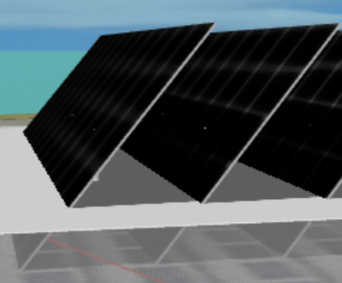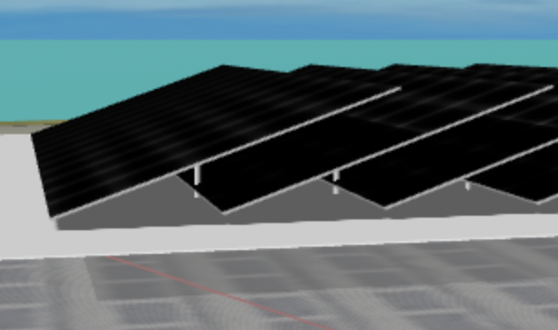

- Open each of your GD designs and inspect if they meet the following constraints. For any design that does not meet either constraint, uncheck the checkbox on the bottom right corner of its thumbnail image in the project to remove it from the parallel coordinate plot.
  - Solar panels cannot overlap or intersect with one another.
  - Solar panels cannot intersect with the ground.
- Generate a scatter plot with “Total Profit” as the X-axis and “Total Mean Yield” as the Y-axis.
- Replace the placeholder plot below with the actual scatter plot.

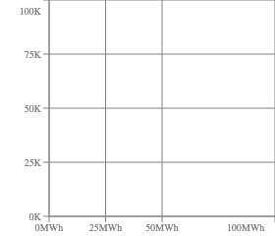

- Which design has the highest yearly total profit?

- Which design has the highest yearly mean yield?

- Which designs are non-dominated?

- Which design achieves the best balance between profit and mean yield? Can you briefly explain why in 1-2 sentences? (There is no “one right answer”.)

