3.4 GD: Iteration

Practice example: Generative solar farm design
Maybe some of the generated solar farm designs already look pretty good to you, but what if there are even better designs to be discovered? As the human designer, you have a few options:
- Rerun GD with the exact same settings. The genetic algorithm it uses involves a certain degree of randomness, so each run may generate different results;
- Change the design objective. In addition to yearly profit and yearly average output, you can also set the objective to yearly total output.
- Change the search ranges of one or more design variables. For example, you can be more creative by searching in new areas in the design space (e.g., designs with wider rows), or be more efficient by avoiding certain areas (e.g., negative tilt angles).

- What do you want to do next? Briefly explain your reasons in 1-2 sentences.

- Generate at least six more designs using any of the three yearly objectives (total output, profit, average output) and curate (duplicate) them to your GD project.

Once you finish all your designs, replace the placeholder plot below with a scatter plot of Profit (X-axis) vs. Mean Yield (Y-axis).

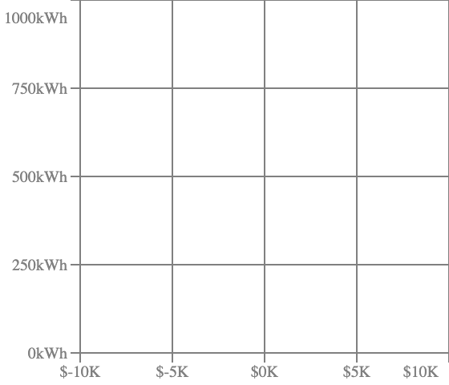

- Compare your six (or more) new designs with your six (or more) old designs. Did you discover any new non-dominated designs? Are there any old non-dominated designs that have now become dominated?

- Out of all 12 (or more) designs, which design achieves the best balance between profit and average output? Can you briefly explain why in 1-2 sentences? (There is no “one right answer”.)

- If you had more time, what else would you try to generate better designs?

