2.1 PD: Problem Definition

Practice example: Parametric solar farm design
We can also define the design of solar farms with a few variables:
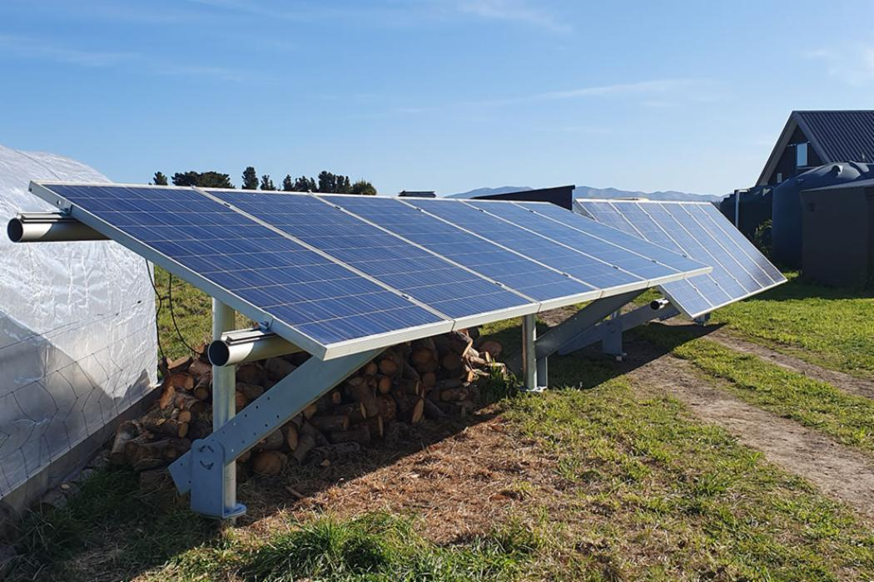
- Tilt angle: How the solar panel is oriented in the vertical direction. An appropriate tilt angle orients a solar panel towards the Sun.
  - 0º = flat (parallel to the ground)
  - 90º = vertical
  - In the photo on the right, the front panels have a lower tilt angle, and the back panels have a higher tilt angle

- Row width: Each row of solar panels may have multiple sub-rows. A wider row casts a longer shadow.
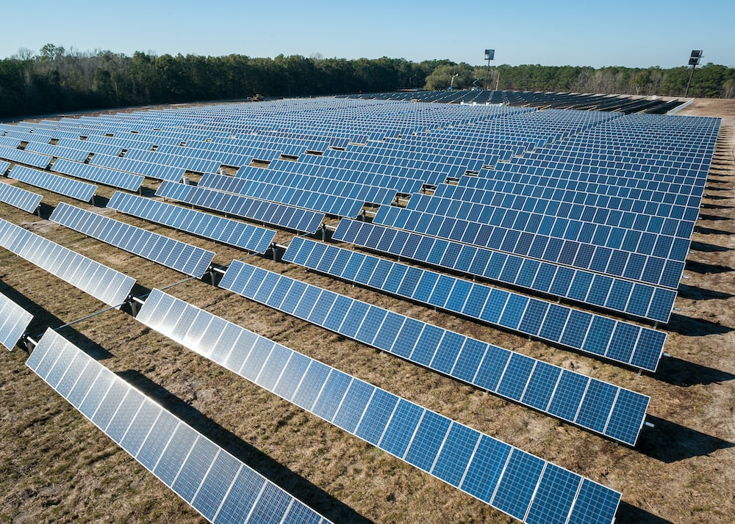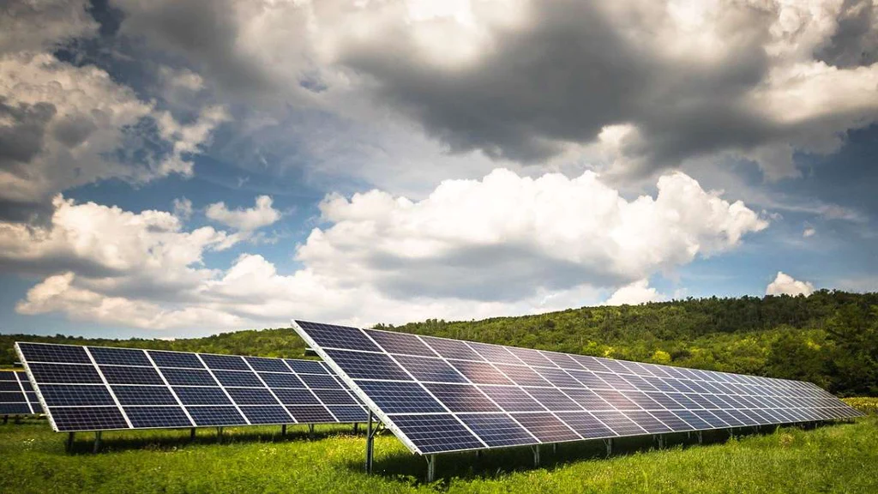
RW = 1 RW = 2 RW = 4

- Because most solar farm designs follow a similar pattern, we can define another variable called “inter-row spacing”. Look at the two examples below:
- Can you provide a definition for “inter-row spacing”?
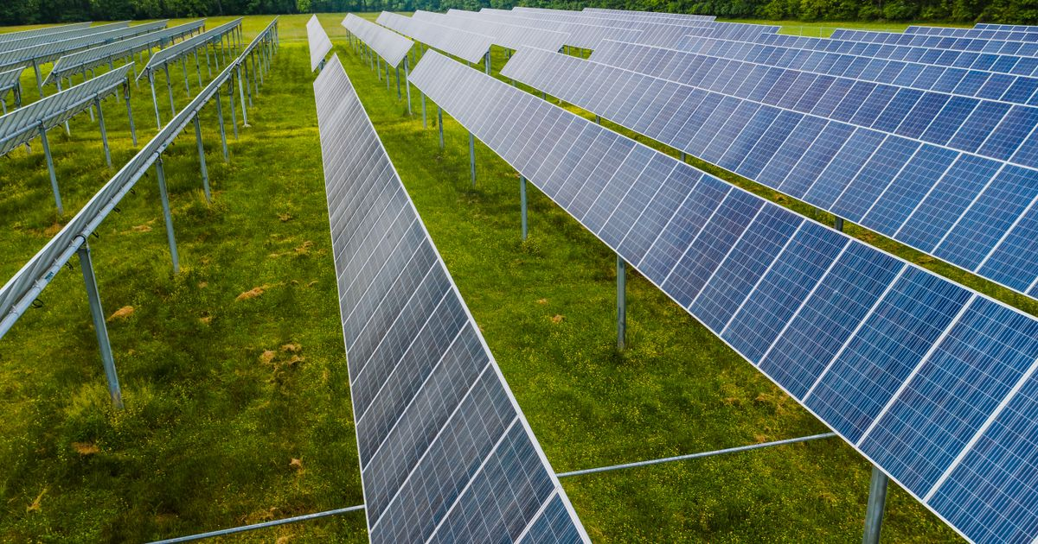

Definition of inter-row spacing (IRS)

2. Imagine you have sketched the solar farm design shown below:
- The width of the field is approximately 50m.
- There are 8 rows of solar panels, equally spaced throughout the field.

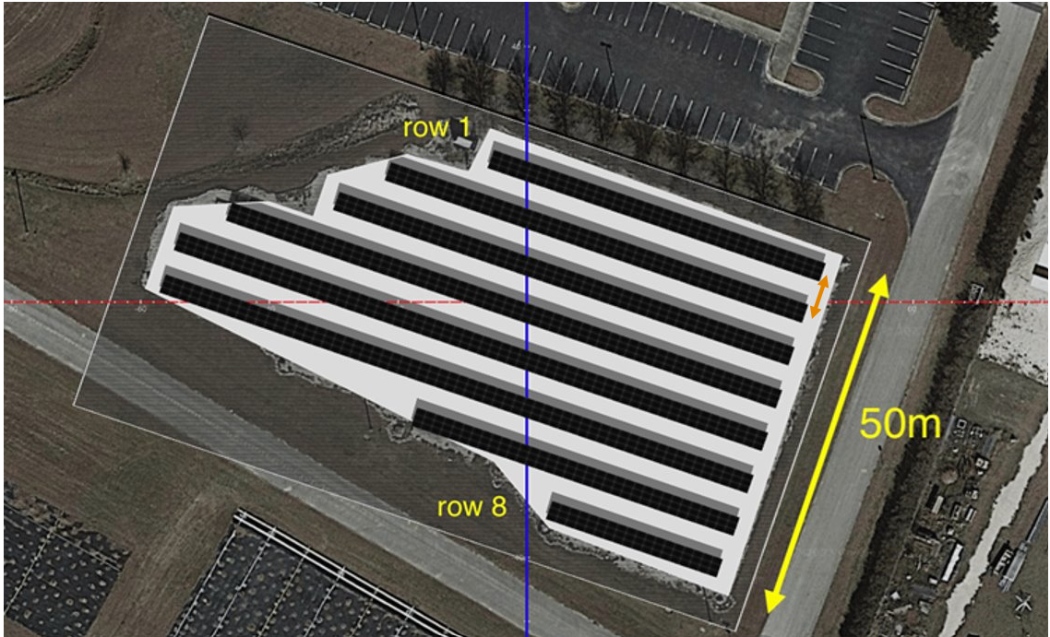
Now you need to calculate the parameters of this design:
- Can you calculate the approximate inter-row spacing of this design? (Assume the IRS is measured center-to-center, not edge-to-edge, see the orange arrow in the above figure.)
- Now that you know the IRS, can you describe a way to calculate the position of each solar panel row using its row number (1-8) and IRS? Feel free to respond with text, pseudo code, or any other format.

