2.2 PD: Exploration

Practice example: Parametric solar farm design

Organize Your Designs with Projects

You can create, view, and compare multiple designs within a single Project. A project template has been provided for you, which contains multiple identical copies of the Pickle solar farm design template. To create your PD designs, simply open one of the design templates in the project; you don’t have to start from scratch.

- Open this Aladdin PD project template. Make sure you are signed in to an account. Select Main menu> Project> Save project as 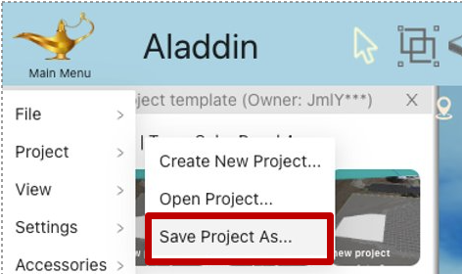
- Double click on a design in a project to open the design 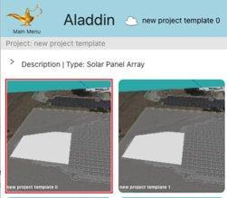
- Your design is open when you see a cloud put on the project panel
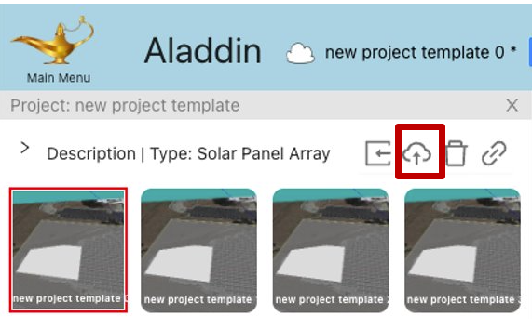

As a refresher, here are the three solar farm design variables you can change:

Property | Explanation | Example
Tilt angle | How the solar panel is oriented in the vertical direction.  An appropriate tilt angle orients a solar panel towards the Sun. | 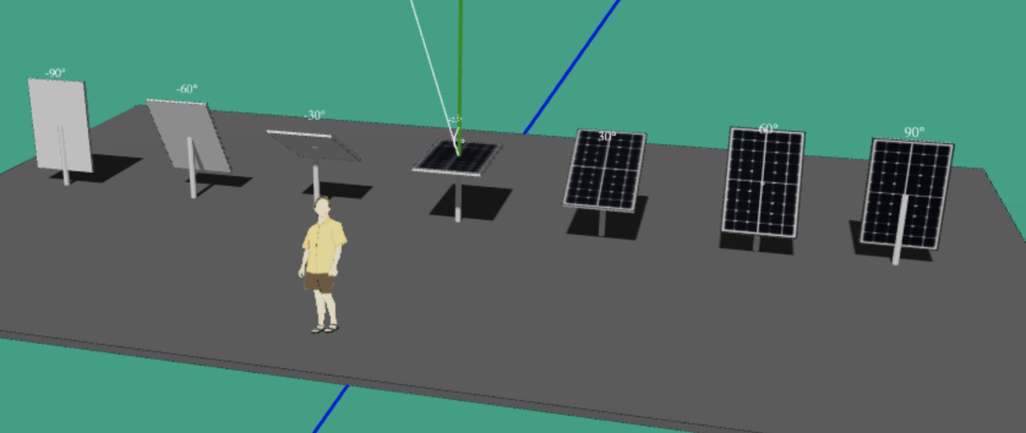
Solar panel row width (RW) | Each row of solar panels may have multiple sub-rows.  A wider row casts a longer shadow. | 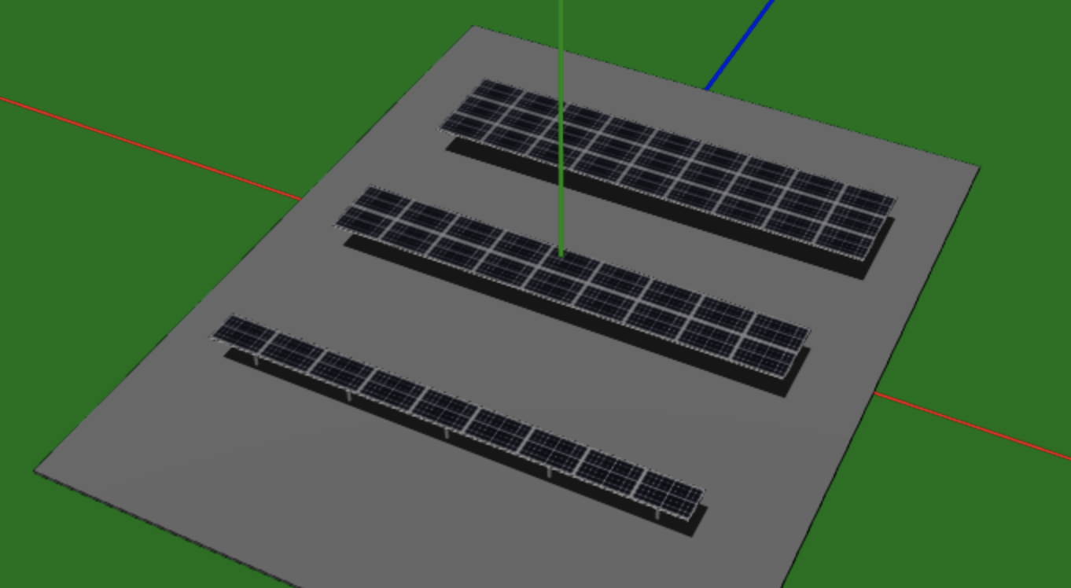
Inter-row spacing (IRS) | The distance between every two rows of solar panels (center-to-center).  If two rows of solar panels are too close together, some panels may be shaded and produce less output. | 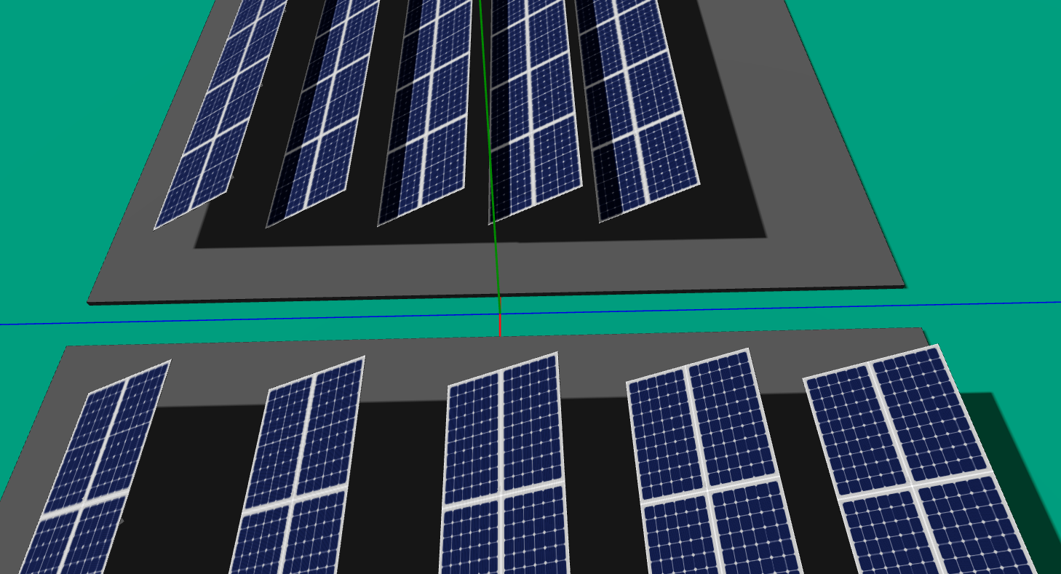

In traditional design, the designer manually adds solar panels and change their position and size to create the desired design. In parametric design, you can simply enter the values for each design variable, and a layout wizard will generate the corresponding design for you.

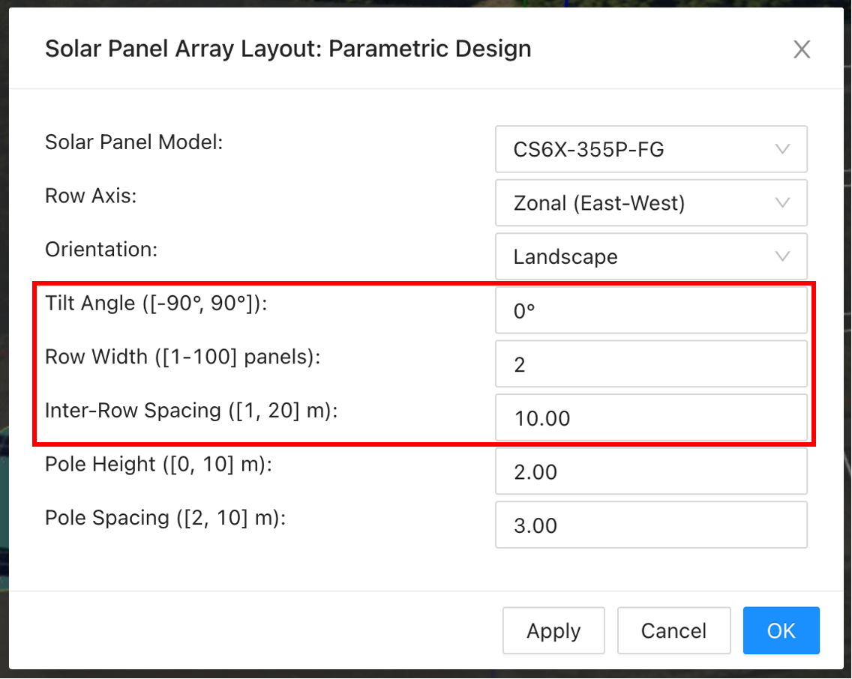
Steps:

- Open your own copy of the PD project and double click on the first design.

- To open the layout wizard, right click on the gray area below the solar farm and select “Layout > Solar Panel Array Layout”.

- Change the three design variables to the desired values and click “OK”.

- The layout wizard will ask you if you want to replace existing solar panels. Click “Yes”.

- Update the selected design  to save your first PD design.
One of the powers of parametric design is to explore the design space much more efficiently. For example, what is the best IRS, if we decide to use RW=3? After a trying a few different values, we may discover that:

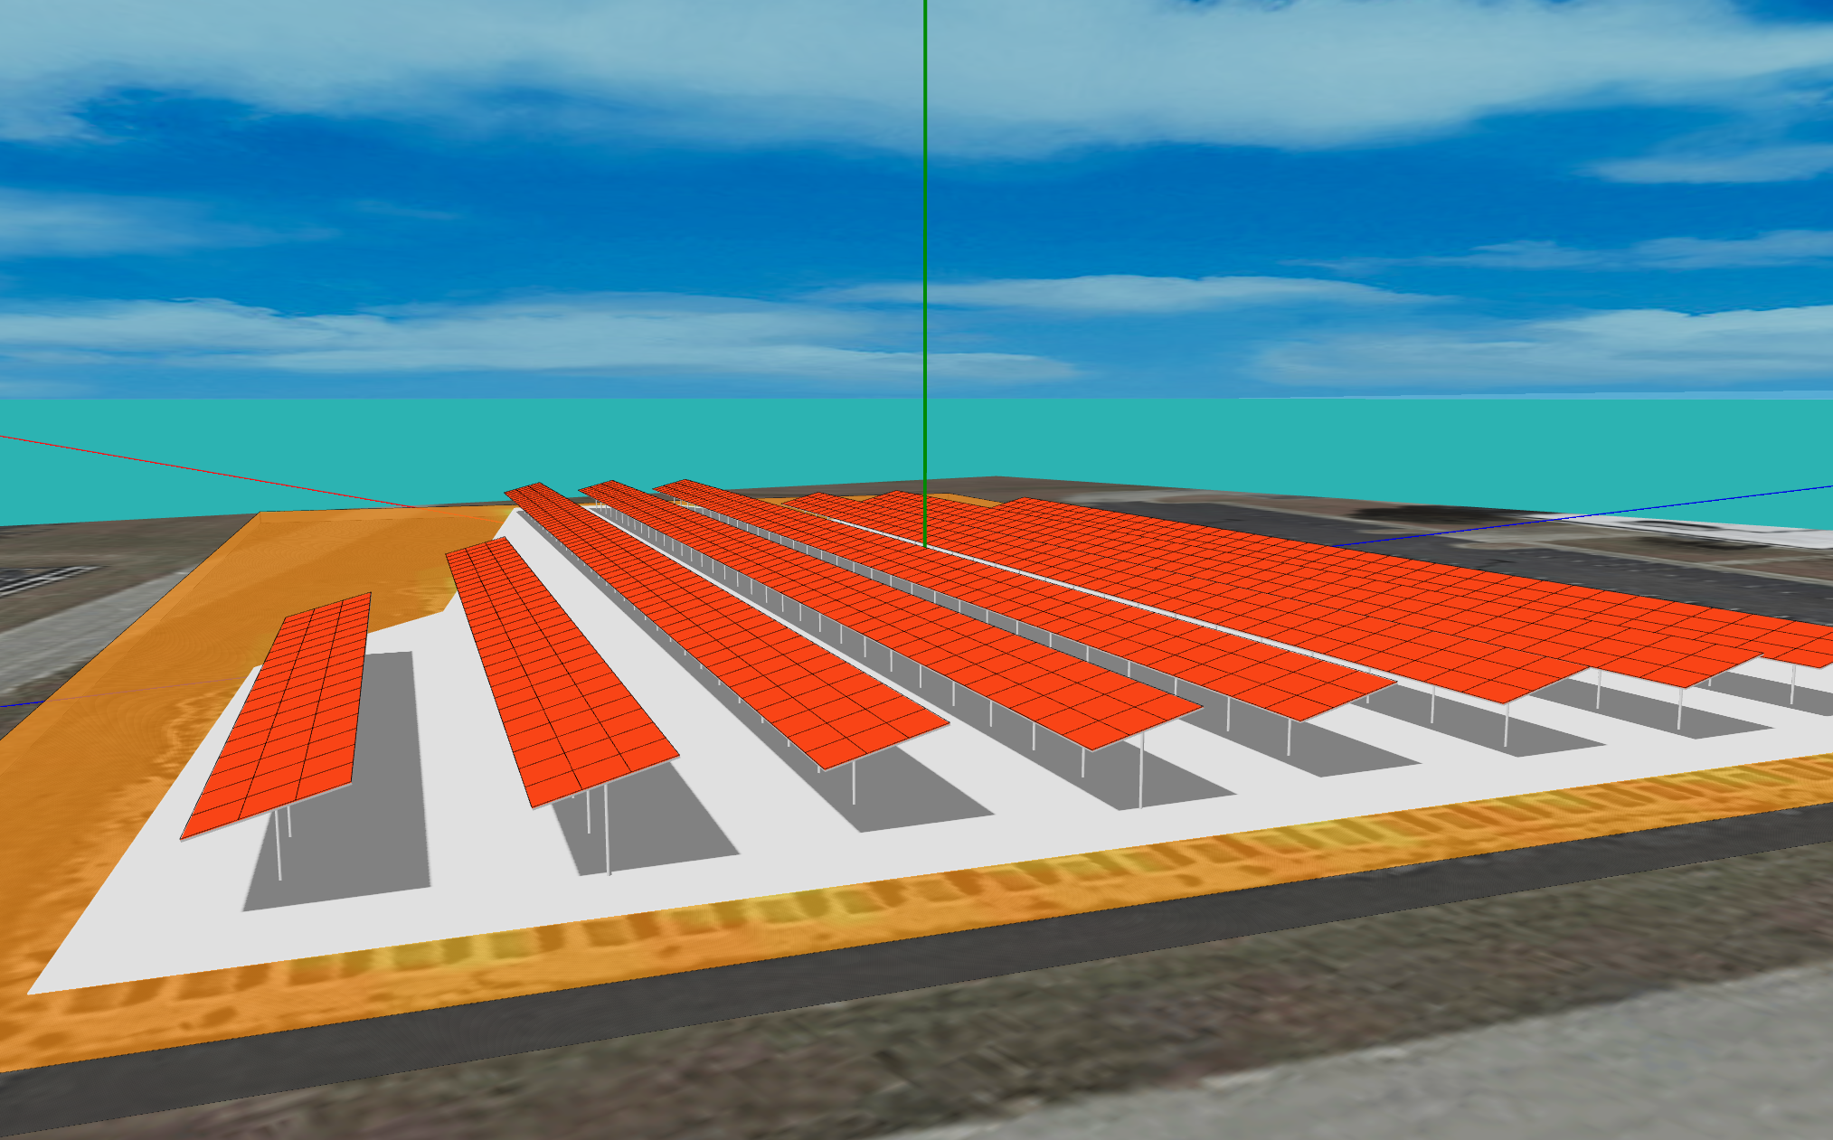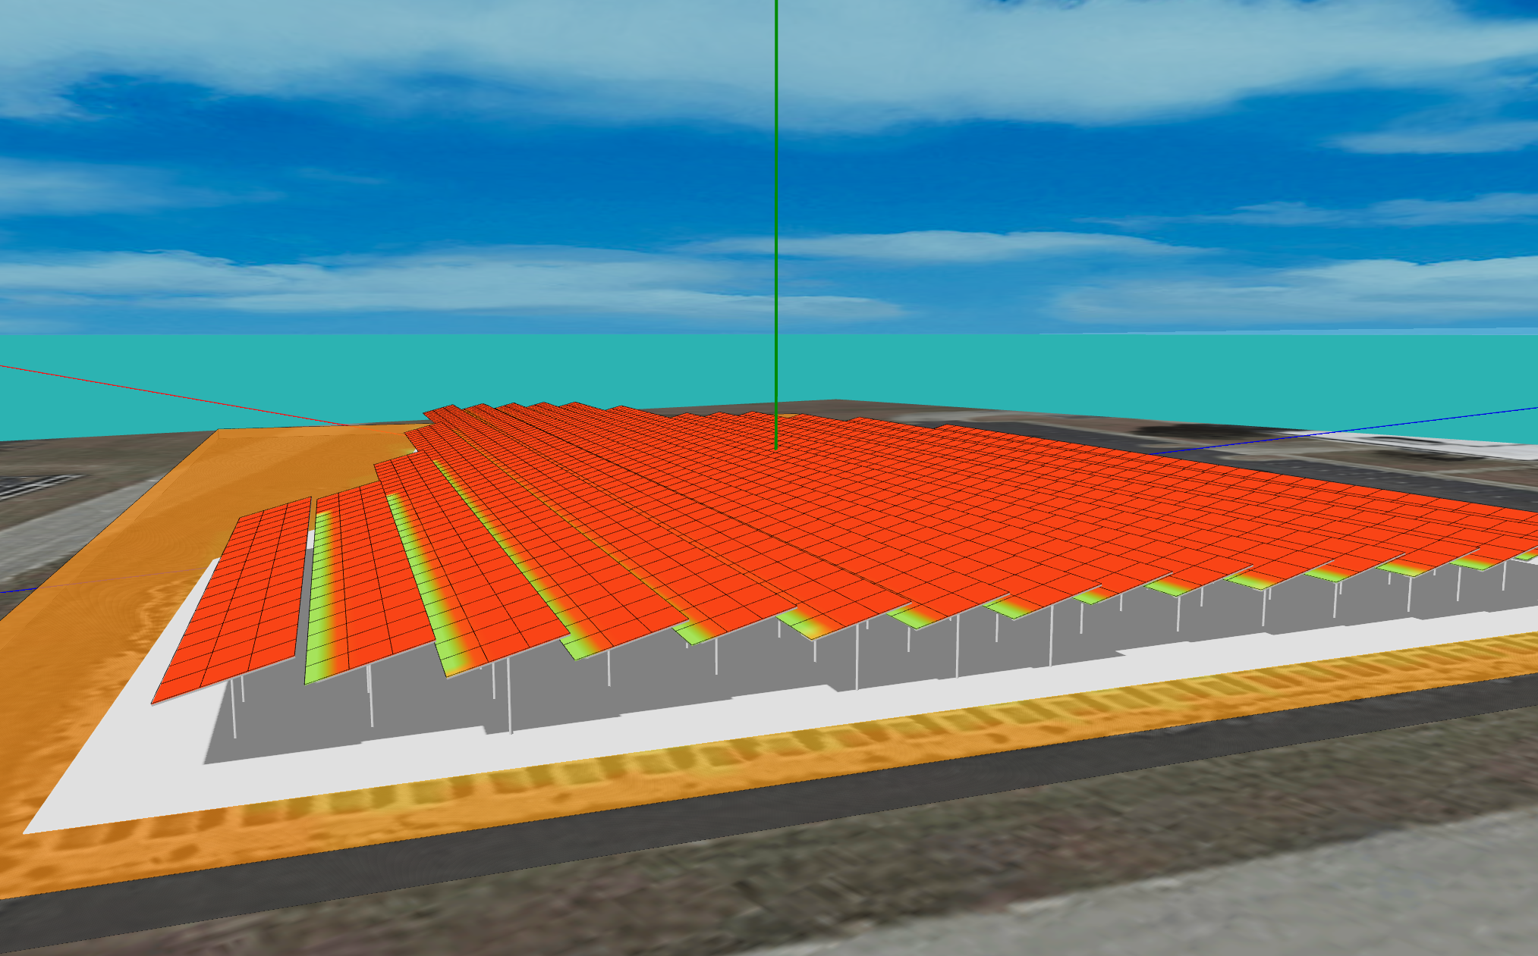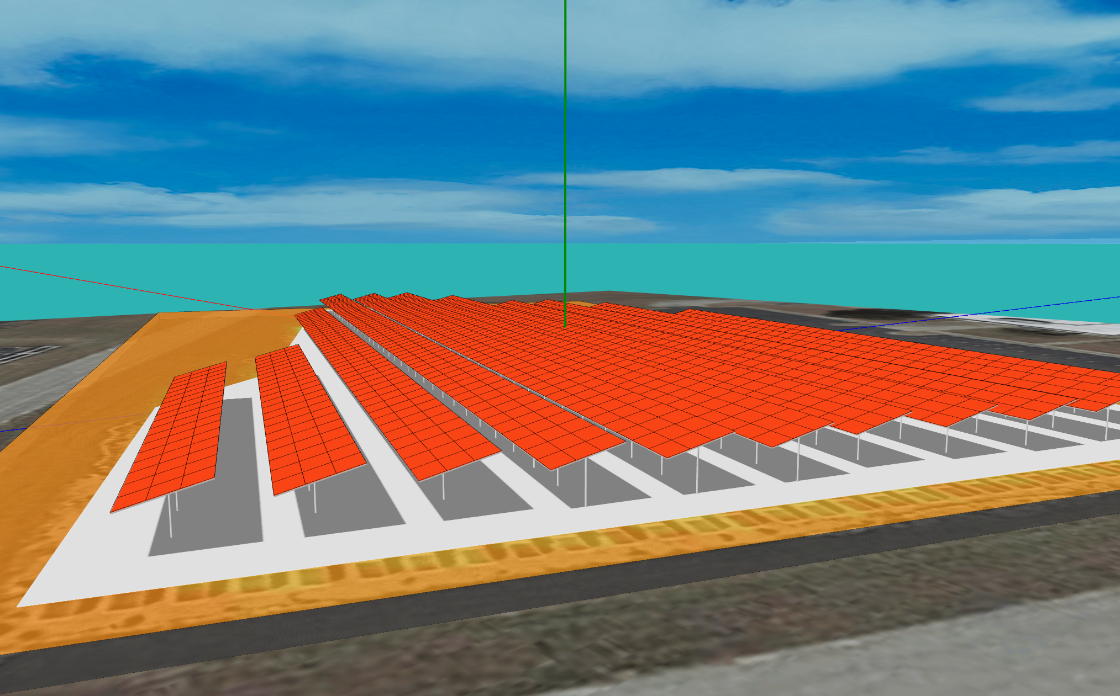
- IRS=6.4 (left): There is too much space between the solar panels.
- IRS=3.2 (middle): The inter-row shading decreases the output of each solar panel.
- IRS=4.8 (right): This layout is more balanced.

Practice example: Parametric solar farm design

- Use parametric design to create the example above (tilt = 15º, RW = 3, IRS = 4.8m) in your PD project.
- Now that you have your first PD design, create two more solar farm designs by yourself and update them in your PD design project.
  - One design with thinner rows (RW=2)
  - One design with wider rows (RW=5)
Find the best IRS for these two designs by trying as many IRS values as you like. [Additional tips: Keep the same tilt angle (we recommend 15º for this task), so you can compare the effect of different IRSs.]
Use the shadow and heatmap visualization  to estimate the “sweet spot.”
What is the best IRS for RW=2?
What is the best IRS for RW=5?

