2.4 PD: Iteration

Practice example: Parametric solar farm design
- Now that you have evaluated your first design, you may decide that an IRS of 4.8m is still too much spacing. Try to add one more row of solar panels to design 1 and maintain an equal IRS without using PD (i.e., make all the changes manually). Spend no more than 5 minutes on your attempt and insert a screenshot of your final progress below. (The goal is for you to experience the difference between TD and PD.)

- You have a few options with your other two designs:
- Converge: Choose what you think is the most promising RW so far (2,3, or 5) and optimize the tilt and IRS.
- Diverge: Try other RWs first, before choosing what you think is the most promising RW and optimizing the tilt and IRS.

Iterate a few more times using parametric design, generate at least three (3) more designs, and curate (duplicate) them to your GD project.
Once you finish all your designs, replace the placeholder plot below with a scatter plot of Profit (X-axis) vs. Mean Yield (Y-axis).

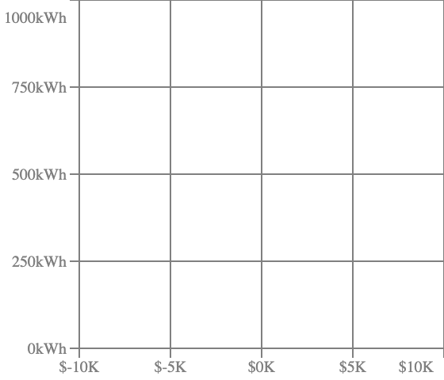
- Which of these designs are now non-dominated?

- Which design achieves the best balance between yearly profit and yearly average output? Can you briefly explain why in 1-2 sentences? (The answer can be subjective.)

