1.4 TD: Iteration

Practice example: Solar farm design
The example design with a small tilt angle and large spacing may already be non-dominated, but how can we further improve it? One idea is to change only the tilt angle, so we can explore its nearby design space bit by bit. The reasoning is that if we tilt the solar panels more towards the Sun, then we may increase the total energy output without increasing the cost.
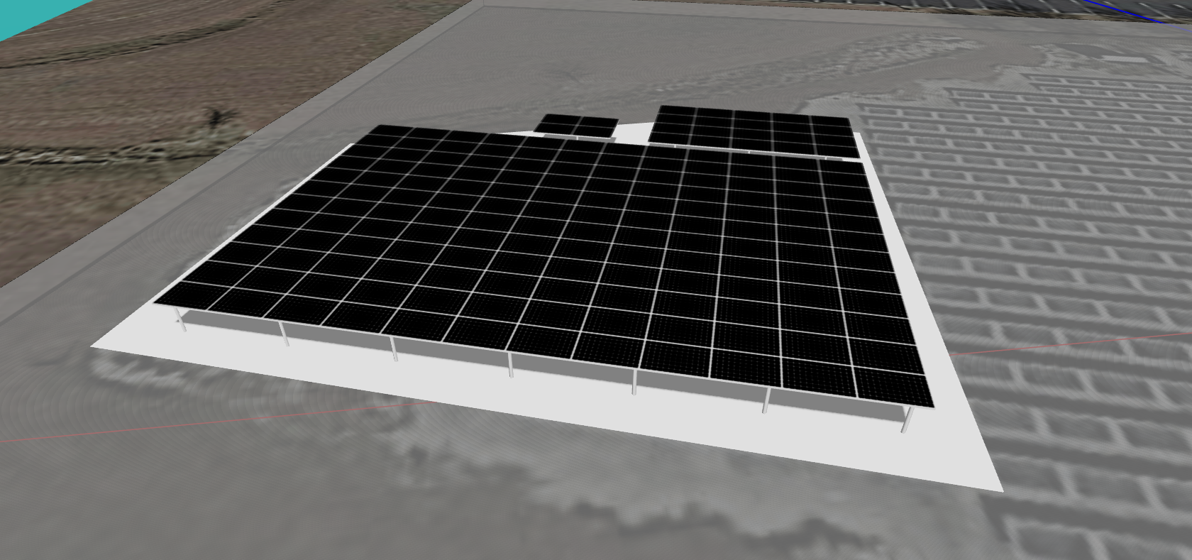
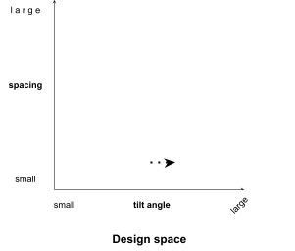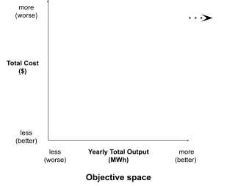

But how much should we change the tilt angle? After several iterations, we may find a sweet spot around 20º that produces the most energy output, and neither a higher tilt (like 30º) nor a lower tilt (like 10º) has a better performance.

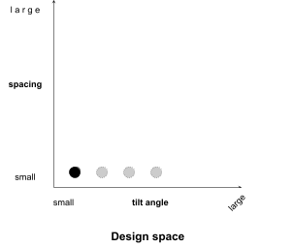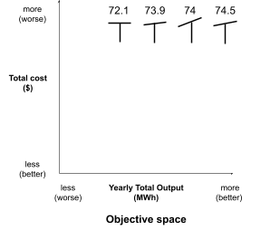

At this point, we can include such a design with both the original small spacing and an improved 20º tilt angle as one of the final design candidates.

It’s your turn to improve your previous designs by iterating a few more times. Here are your options in Aladdin:
- Add new solar panels
- Delete existing solar panels
- Move, rotate, and expand solar panels
- Change the angle of solar panels
- Copy and paste solar panels

- In Design 2, the solar panels are already tilted towards the Sun, but there is too much space among solar panels. Can you iterate on Design 2 by changing the spacing between solar panels while keeping the same tilt angle?
- Copy the green table from page 18 into the green table below.
- Save your best iteration as a cloud file.

 | Design 1 | Design 2 | Design 3 | Design 1.1 | Design 2.1 | Design 3.1
Variable: Tilt angle | Small (0º) | large | [Insert your own design choices] | Larger (20º) | large | [Insert your own design choices]
Variable: Spacing | small | large | [Insert your own design choices] | small | smaller | [Insert your own design choices]
Screenshot (optional) |  |  |  | 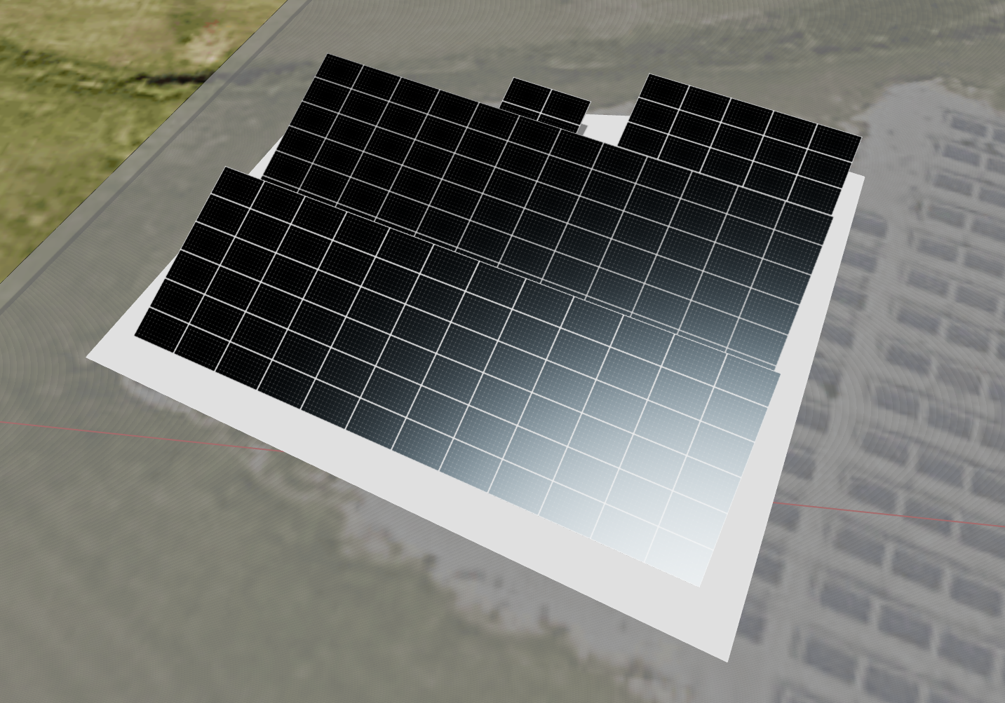
Objective: Yearly total output (kWh) | 72135.16 |  |  | 74474.07
Objective: Yearly average output (kWh) | 429.38 |  |  | 443.30
Objective: Total cost ($) | 9198 |  |  | 9198
Objective: Profit ($) | 1622.27 |  |  | 1973.11

- Which of the six designs in the table above are now non-dominated in terms of profit and average output?

- Which design achieves the best balance between a high profit and a high average output? Can you briefly explain why in 1-2 sentences? (The answer can be subjective.)

